**INT 213**



**PYTHON PROJECT**

## **Topic:**

**Final Project Report**

**VEHICLE PARKING MANAGEMENT SYSTEM**

**Submitted To:** Mr. Sagar Pande Sir

**D.O.S**: November 3, 2020

**Section:** K19JC

## **Group Members :**

|  |  |  |
| --- | --- | --- |
| **Name** | **Registration No.** | **Roll No.** |
| Dipraj Daripa | 11911828 | 39 |
| Sujit Kumar Mishra | 11908354 | 60 |
|  |  |  |

**ACKNOWLEDGEMENT**

We would like to express our Special thanks of Gratitude to our University as well as our INT213 Faculty Mr. Sagar Pande Sir, who gave us this opportunity to work on the project “Vehicles Parking Management System**”,** which Also Helped us in learning more new things.

*Finally, I would like to thank my friends who helped me a lot in finishing this topic within a limited time.*

Thanks to All!

***

**Table of Contents :**

### Chapter 1. Introduction

1. Introduction to the System
2. Problem Definition
3. Aim
4. Objective
5. Goal
6. Need of System

### Chapter 2. Hardware and Software requirement

1. Introduction
2. System environment
3. Software requirement
4. Hardware requirements

### Chapter 3. System Analysis

1. Purpose
2. Project Scope
3. Existing System
4. Proposed System
5. System Description

### [Chapter 4.Implementation issues](#chap 8)

1. Python
2. HTML
3. Cascading style sheet(CSS)
4. Sqlite

**Chapter 5. System Design**

1. Introduction
2. Conceptual Design
3. ER-Diagram
4. Logical Design
5. Physical Design
6. Data Flow Diagram

### [Chapter 6.User Screens](#chap 8)

[**Chapter 8. Conclusion**](#chap 9)

1. Features of “Vehicle Parking Management System”
2. Benefits Accrued from “VPMS”
3. Limitations of “VPMS”

**CHAPTER # 1 :**

**Introduction**

***Contents:***

* Introduction
* Abstruct
* Problem Definition
* Need of System

**Abstract**

Vehicle Parking Management System maintains a good record of vehicles check in and checkout time. Both two wheeler & four wheeler can be managed by this system and have different pricing system.

Vehicle parking management system that enables the time management and control of vehicles by using parking number.

The system that will track the entry and exit of vehicles, maintain a listing of vehicle within the parking lot, and determine the parking and it will also determine the cost of parking of vehicle.

**Introduction to the System:**

Vehicle Parking Management system is a web-based technology that will manage the records of the incoming and outgoing vehicles in a parking house. It’s an easy for Admin to retrieve the data if the vehicle has been visited through number he can get that data. Vehicle parking management system is an automatic system which delivers data processing in very high speed in systematic manner.

**Problem Definition:**

In present all vehicles parking work done on the paper. The whole year vehicle parking record is stored in the registers. We can’t generate reports as per our requirements because its take more time to calculate the vehicle parking report.

**Disadvantage of present system:**

* **Not user friendly:** The present system not user friendly because data is not stored in structure and proper format.
* **Manual Control:** All report calculation is done manually so there is a chance of error.
* **Lots of paper work:** Vehicle records maintain in the register so lots of paper require storing details.
* **Time consuming**

**Need of the System:**

There is always a need of a system that will provide a way to effectively control records & track vehicle parking traffic.

Thus, there is a big need of developing vehicle parking management system is to computerized the traditional way of parking management. Another need for developing this application is to generate the report automatically.

**CHAPTER # 2 :**

**Hardware and Software Requirements :**

***Contents:***

##### Introduction

* System environment
* Software requirement
* Hardware requirements

**Introduction:**

In this chapter we mentioned the software and hardware requirements, which are necessary for successfully running this system. The major element in building systems is selecting compatible hardware and software. The system analyst has to determine what software package is best for the **“Online Vehicle Parking Management System”** and, where software is not an issue, the kind of hardware and peripherals needed for the final conversion.

**System Environment:**

After analysis, some resources are required to convert the abstract system into the real one.

The hardware and software selection begins with requirement analysis, followed by a request for proposal and vendor evaluation.

Software and real system are identified. According to the provided functional specification all the technologies and its capacities are identified. Basic functions and procedures and methodologies are prepared to implement. Some of the Basic requirements such as hardware and software are described as follows: -

**Hardware and Software Specification**

**Software Requirements:**

* Technology: Python Django
* IDE : Pycharm/Atom
* Client Side Technologies: HTML, CSS, JavaScript , Bootstrap
* Server Side Technologies: Python
* Data Base Server: Sqlite
* Operating System: Microsoft Windows/Linux

**Hardware Requirements:**

* Processor: Pentium-III (or) Higher
* Ram: 64MB (or) Higher
* Hard disk: 80GB (or) Higher

**CHAPTER # 3 :**

**System Analysis**

***Contents:***

##### Purpose

* Project Scope
* Existing System
* Proposed System
* System Overview

### Purpose:

1. The purpose of developing vehicle parking management system is to computerized the tradition way of vehicle parking. Another purpose for developing this application is to generate the report automatically.

**Project Scope:**

In the modern age. Many people have vehicles. Vehicle is now a basic need. Every place is under the process of urbanization. There are many corporate offices and shopping centers etc. There are many recreational places where people used to go for refreshment. So, all these places need a parking space where people can park their vehicles safely and easily. Every parking area needs a system that records the detail of vehicles to give the facility. With the help of this system we can deliver a good service to customer who wants to park their vehicle into the any organization’s premises.

The project has a wide scope, as it is not intended to a particular organization. This project is going to develop generic software, which can be applied by any businesses organization. More over it provides facility to its users. Also the software is going to provide a huge amount of summary data.

**Proposed System:**

Vehicle Parking Management system is a web-based technology that will manage the records of the incoming and outgoing vehicles in a parking house.

**System Overview:**

The key features required in the system are as follows:

**Dashboard**: In these sections, admin can briefly view the number of vehicle entries in a particular period.

**Category**: In this section, admin can manage category (add/update).

**Add Vehicle**: In this section, admin add vehicle which is going to park.

**Manage Vehicle**: In this section, admin can manage incoming and outgoing vehicle and admin can also add parking charges and his/her remarks.

**Reports**: In this section admin can generate vehicle entries reports between two dates.

**Search**: In this section, admin can search a particular vehicle by parking number.

Admin can also update his profile, change the password and recover the password.

**C****HAPTER # 4 :**

**Implementation issues**

**Python**

Python is a widely used general-purpose, high level programming language. It was initially designed by Guido van Rossum in 1991 and developed by Python Software Foundation. It was mainly developed for emphasis on code readability, and its syntax allows programmers to express concepts in fewer lines of code.

Python is a programming language that lets you work quickly and integrate systems more efficiently.

Python is dynamically typed and garbage-collected. It supports multiple programming paradigms, including procedural, object-oriented, and functional programming. Python is often described as a "batteries included" language due to its comprehensive standard librar

**HTML**

HTML (Hypertext Markup Language) is the set of markup symbols or codes inserted in a file intended for display on a World Wide Web browser page. The markup tells the Web browser how to display a Web page's words and images for the user. Each individual markup code is referred to as an element (but many people also refer to it as a tag). Some elements come in pairs that indicate when some display effect is to begin and when it is to end.

**CASCADING STYLE SHEET (CSS)**

Cascading Style Sheets (CSS) are a collection of rules we use to define and modify web pages. CSS are similar to styles in Word. CSS allow Web designers to have much more control over their pages look and layout. For instance, you could create a style that defines the body text to be Verdana, 10 point. Later on, you may easily change the body text to Times New Roman, 12 point by just changing the rule in the CSS. Instead of having to change the font on each page of your website, all you need to do is redefine the style on the style sheet, and it will instantly change on all of the pages that the style sheet has been applied to. With HTML styles, the font change would be applied to each instance of that font and have to be changed in each spot.

CSS can control the placement of text and objects on your pages as well as the look of those objects.

HTML information creates the objects (or gives objects meaning), but styles describe how the objects should appear. The HTML gives your page structure, while the CSS creates the “presentation”. An external CSS is really just a text file with a .css extension. These files can be created with Dreamweaver, a CSS editor, or even Notepad.

The best practice is to design your web page on paper first so you know where you will want to use styles on your page. Then you can create the styles and apply them to your page.

**Javascript**

JavaScript is a programming language commonly used in web development. It was originally developed by Netscape as a means to add dynamic and interactive elements to websites. While JavaScript is influenced byJava, the syntax is more similar to C and is based on ECMAScript, a scripting language developed by Sun Microsystems.

JavaScript is a client-side scripting language, which means the source code is processed by the client's web browser rather than on the web server. This means JavaScript functions can run after a webpage has loaded without COMMUNICATING with the server. For example, a JavaScript function may check a web form before it is submitted to make sure all the required fields have been filled out. The JavaScript code can produce an error message before any information is actually transmitted to the server.

Like server-side scripting languages, such as PHP and ASP, JavaScript code can be inserted anywhere within the HTML of a webpage. However, only the output of server-side code is displayed in the HTML, while JavaScript code remains fully visible in the source of the webpage. It can also be referenced in a separate .JS file, which may also be viewed in a browser.

**Django**

Django is a web application framework written in Python programming language. It is based on MVT (Model View Template) design pattern. The Django is very demanding due to its rapid development feature. It takes less time to build application after collecting client requirement.

This framework uses a famous tag line: **The web framework for perfectionists with deadlines.**

**CHAPTER # 5 :**

**System Design**

***Contents:***

* Use case diagram
* ER diagram
* Data flow diagram

**Use Case Diagram:**

**Admin**

**ER DIAGRAM**

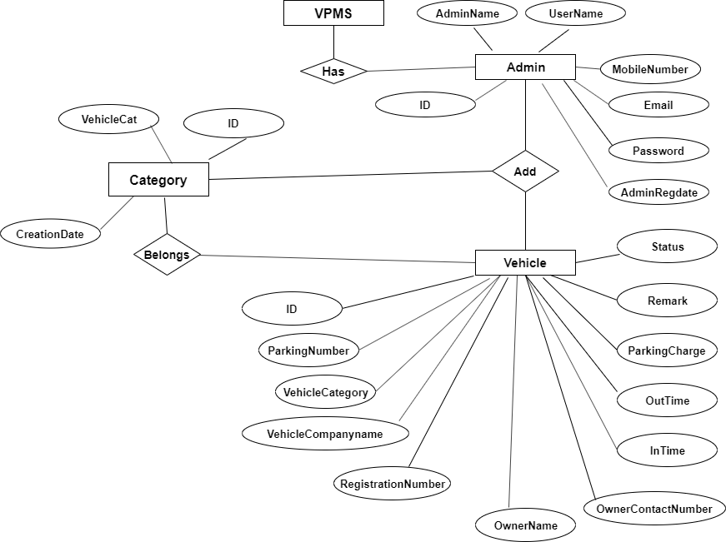

**DFD (Data Flow Diagram)**

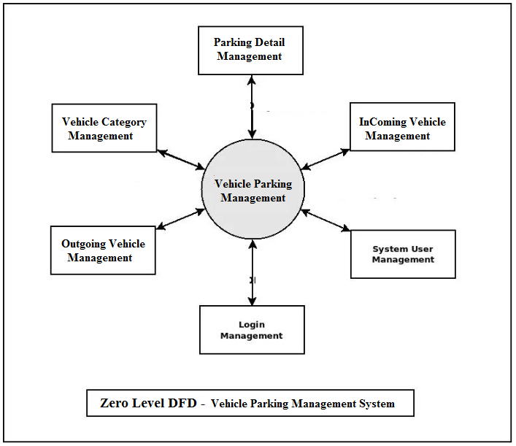

**CHAPTER # 6 :**

**Output screens**

**HOME PAGE :**

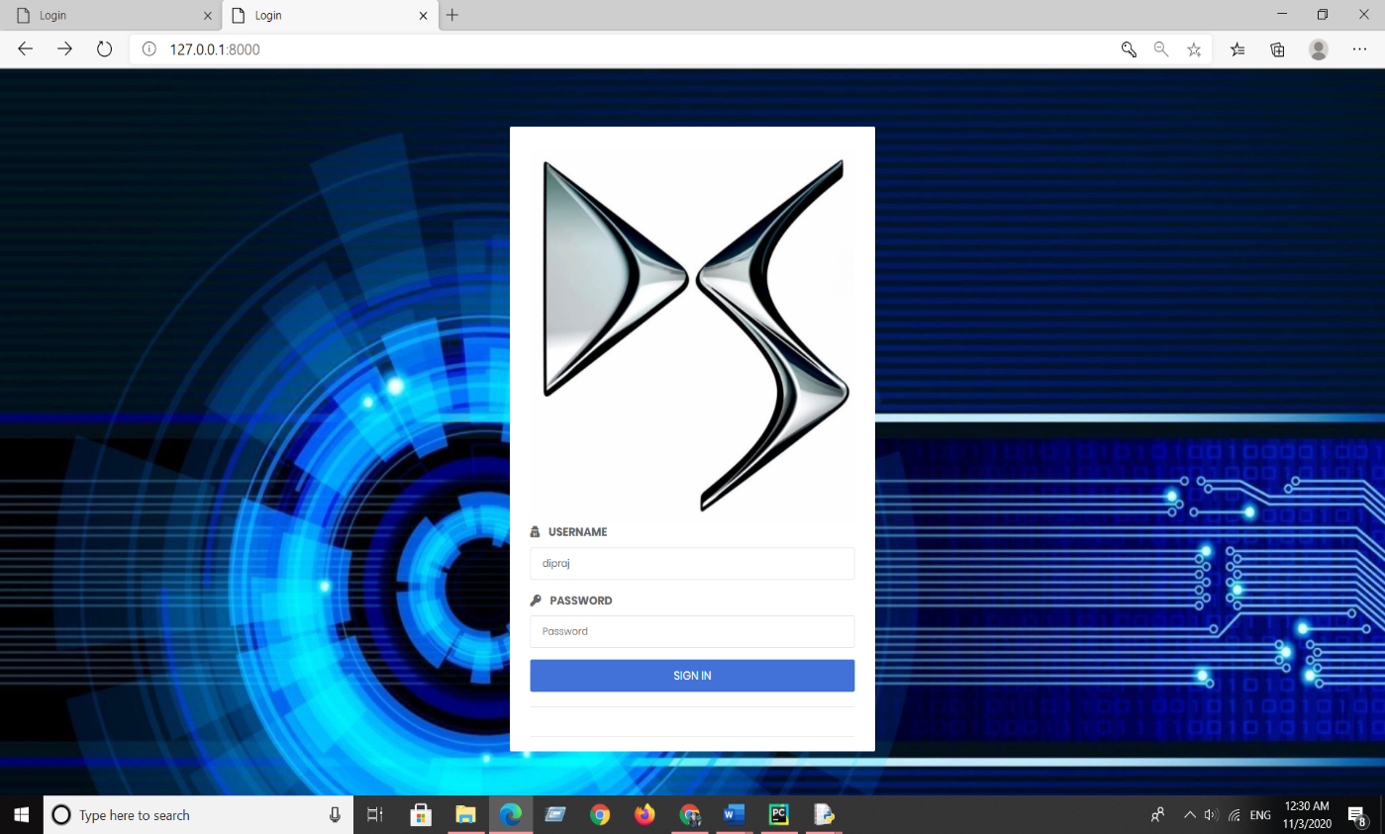

**DASHBOARD :**

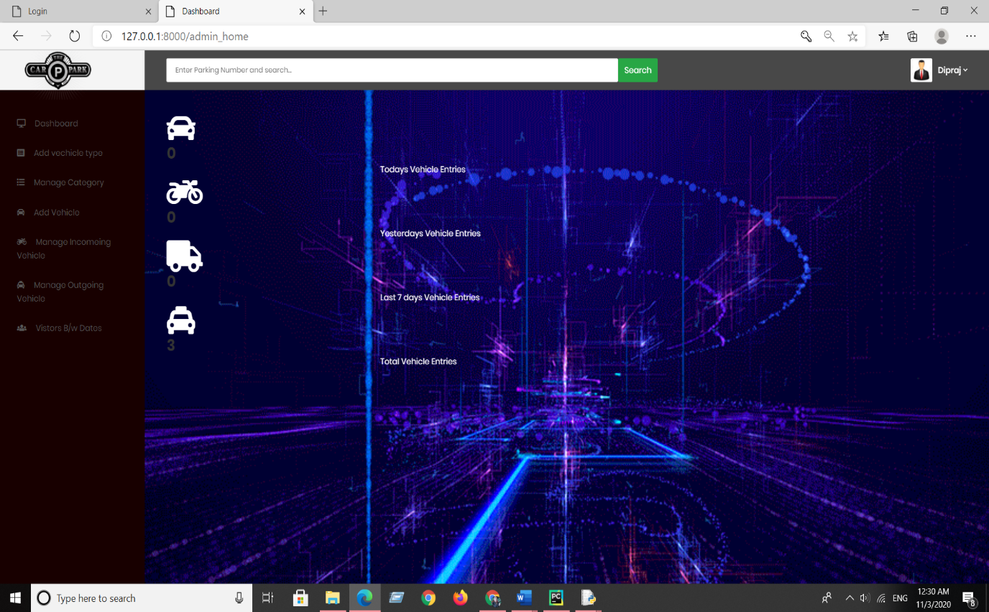

**ADD VEHICLE CATEGORY :**

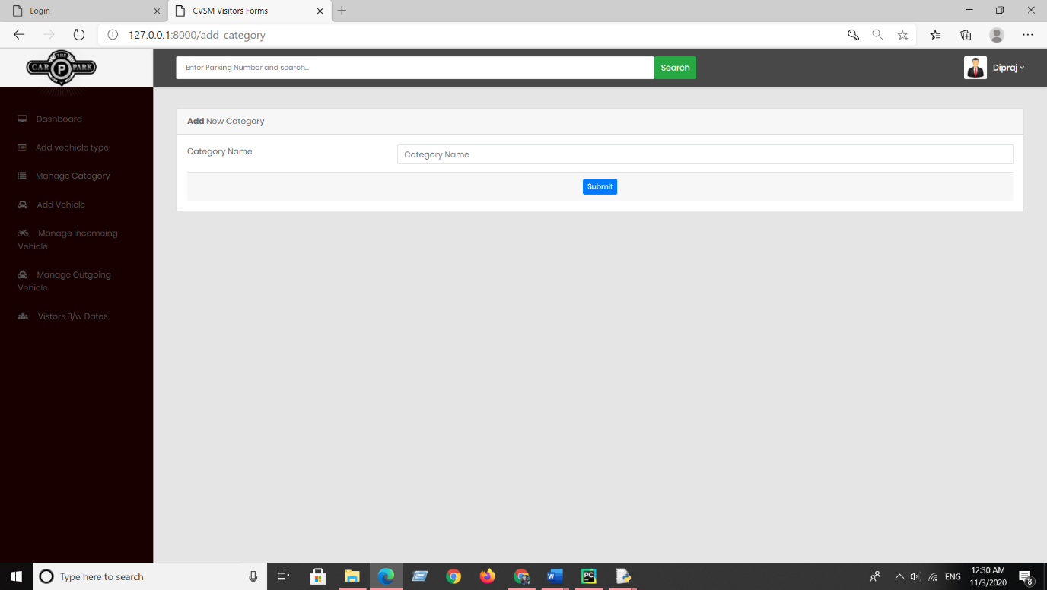

**MANAGE CATEGORY :**

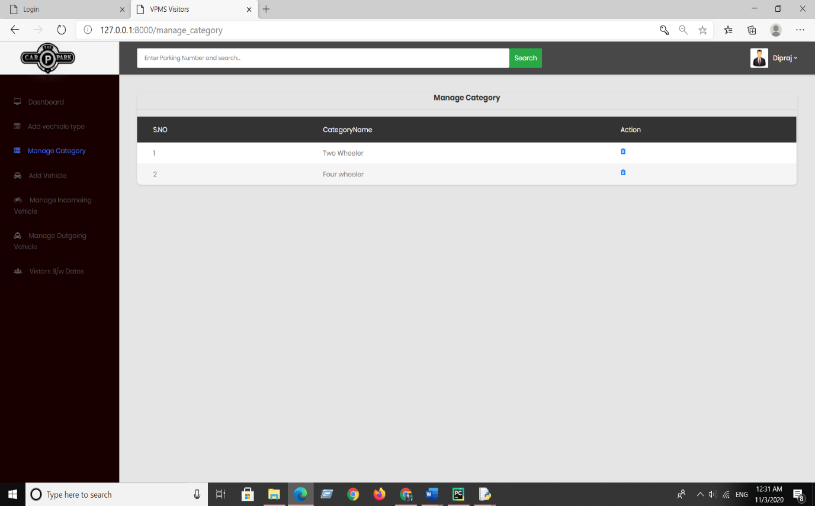

**ADD VEHICLE :**

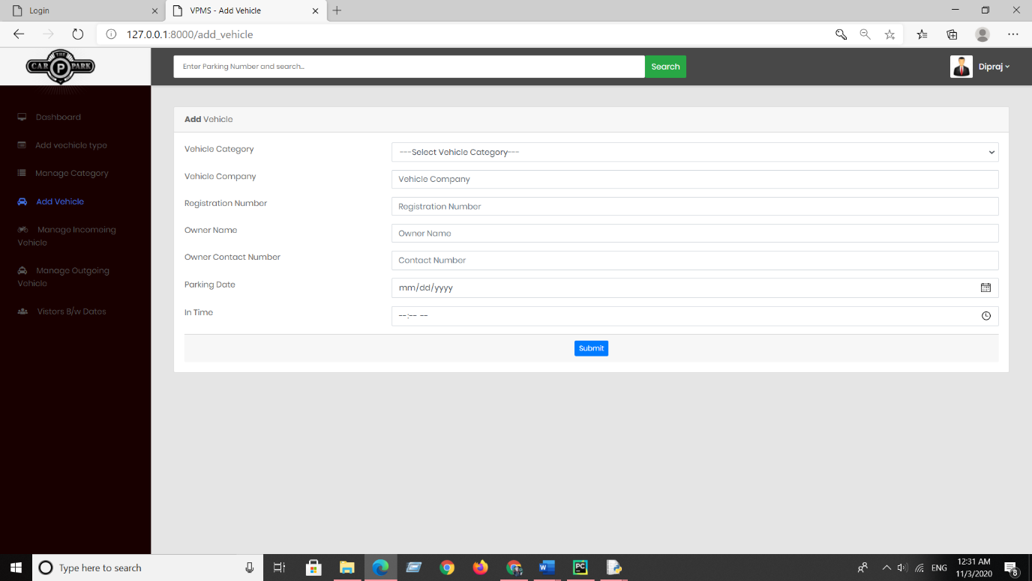

**MANAGE INCOMING VEHICLE :**

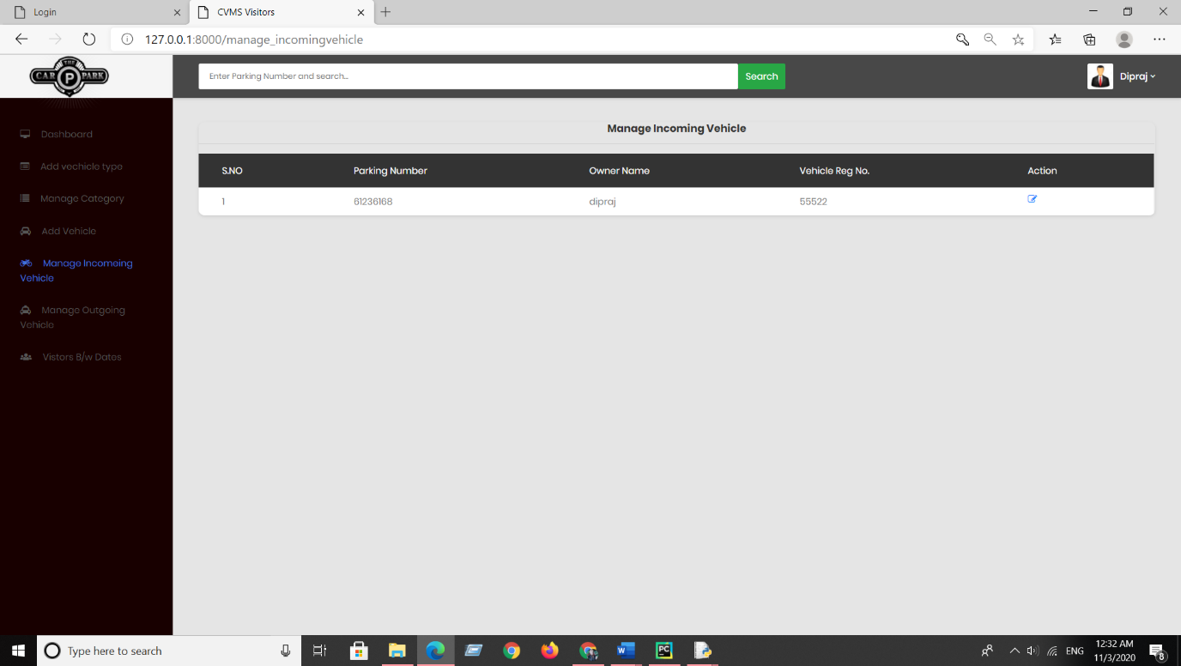

**MANAGE OUTGOING VEHICLE :**

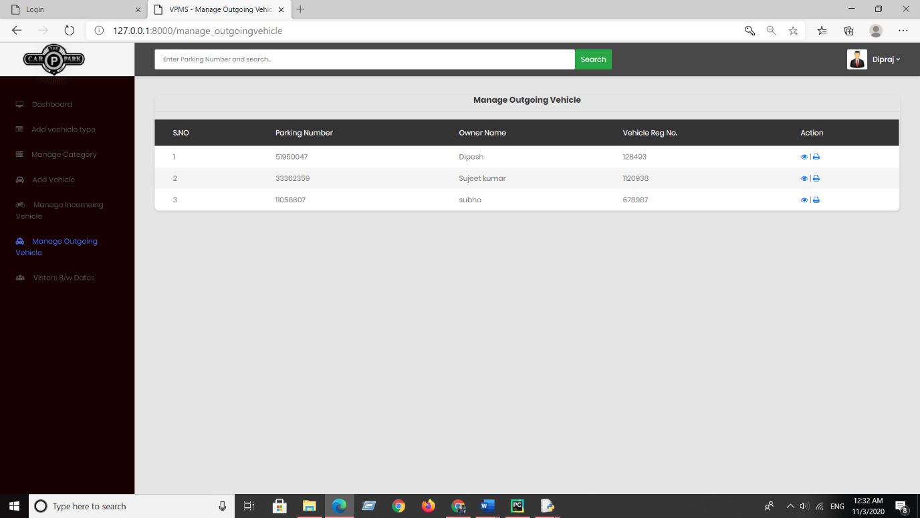

**SEND THE BILL RECEIPT THROUGH THE EMAIL :**

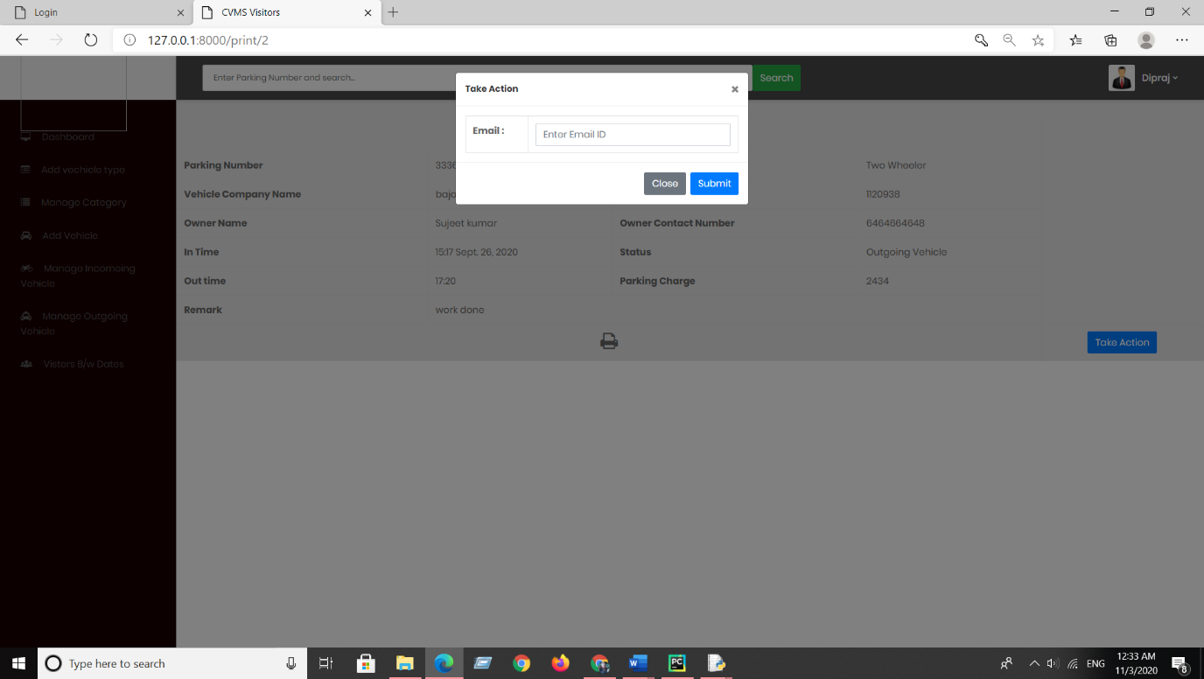

**PRINT THE BILL RECEIPT :**

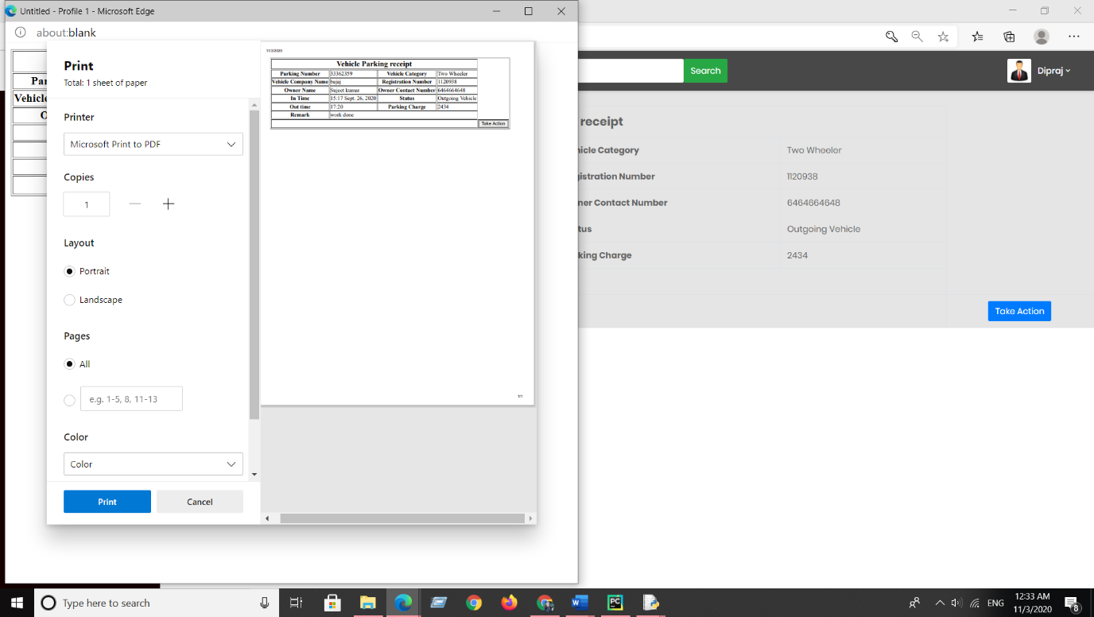

**VISITORS B/W DATE :**

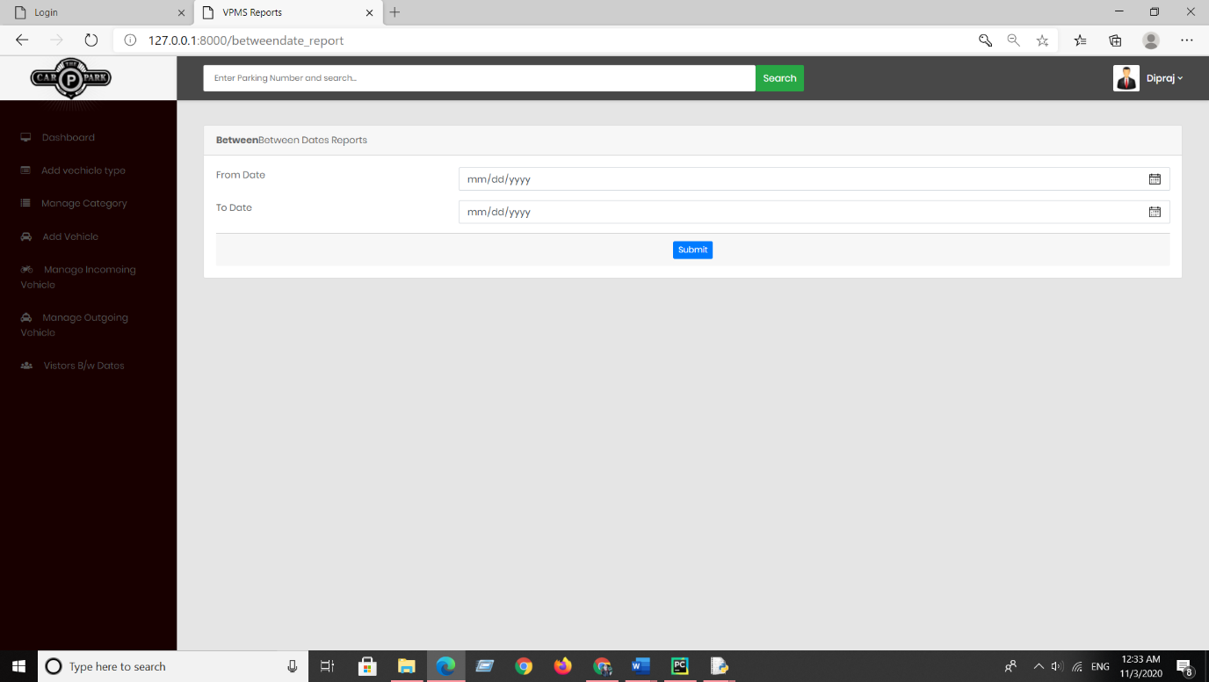

**CHAPTER # 8 :**

**Future Scope**

**FUTURE SCOPE**

Thisweb application involves almost all the basic features of the online vehicle parking management system. The future implementation will be online help for the users and chatting with website administrator.

**CONCLUSION**

The project entitled “Online Vehicle Parking Management System” is developed using HTML, CSS and Bootstrap as front end and Python Django and Sqlite database in back end to computerize the process of company visitor management. This project covers only the basic features required.

**Bibliography :**

**BIBLIOGRAPHY**

* Wikipedia
* <https://www.geeksforgeeks.org/python-django/>
* <https://www.javatpoint.com>
* <https://www.python.org/>
* <https://www.tutorialspoint/>
* **REFERENCE BOOKS**
* Two scoops of Django for 1.11 by Daniel Greenfeld’s and Audrey Greenfield

### Lightweight Django by Elman and Mark Lavin